AIR QUALITY MONITORING

CIRCUIT DIAGRAM

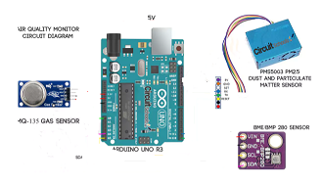

MQ-135 gas sensor:

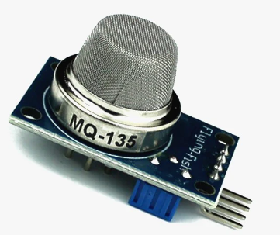 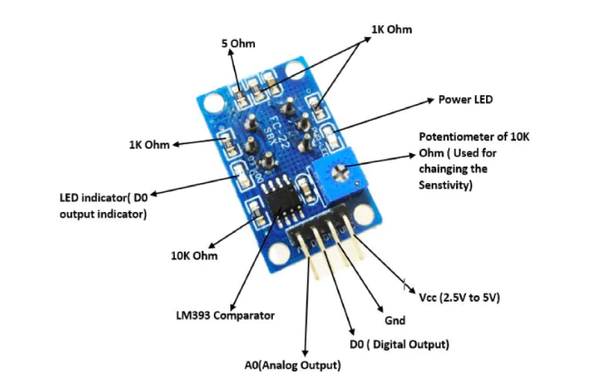

The MQ-135 is a sensor that is responsible for detecting gases such

as ammonia, alcohol, benzene, smoke and carbon dioxide. It

contains basic electronics to be able to interface with a

microcontroller, it has 2 outputs, one analog and one digital

The **MQ-135 Gas sensor** can detect gases like Ammonia (NH3), sulfur (S), Benzene (C6H6), CO2, and other harmful gases and smoke. Similar to other MQ series gas sensor, this sensor also has a digital and analog output pin. When the level of these gases go beyond a threshold limit in the air the digital pin goes high. This threshold value can be set by using the on-board potentiometer. The analog output pin, outputs an analog voltage which can be used to approximate the level of these gases in the atmosphere.

The MQ135 air quality sensor module operates at 5V and consumes around 150mA. It requires some pre-heating before it could actually give accurate results.

* Operating Voltage: 2.5V to 5.0V
* Power consumption: 150mA
* Detect/Measure: NH3, Nox, CO2, Alcohol, Benzene, Smoke
* Typical operating Voltage: 5V
* Digital Output: 0V to 5V (TTL Logic ) @ 5V Vcc
* Analog Output: 0-5V @ 5V Vcc

**Detect Harmful Gases using Digital Pin:**

The digital output pin of the sensor can be used to detect harmful gases in the environment. The sensitivity of the digital pin can be controlled by using the 10k potentiometer. If the gas is detected the indicator LED D0 will turn on and the digital pin will go from logic high to logic low (0V). The LM393 Op-Amp Comparator IC is used to compare the actual gas value with the value set using the potentiometer. If the actual gas value increases than the set value then the digital output pin gets low.

PM2.5 Dust and Particulate Matter Sensor

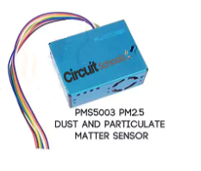

With the PMS5003 PM2.5 Air Quality Sensor you can reliably measure the concentration of PM2.5 particles (which refers to the concentration of particles 2.5 microns in diameter or less The sensor uses the scattering of laser light to irradiate the suspended particles in the air, then captures the scattered laser light and gets a fairly accurate estimate of the amount of suspended particles per unit volume through a microprocessor. In the above circuit we connected 3 sensor boards. Initially we connected MQ135 with 5v VCC power supply and GND from Arduino and connected the AOUT to the analog A0 pin on Arduino. Then connected BME 280 with 3.3V  and GND from Arduino to VIN and GND of BME 280 respectively. then SCL pin to A5 and SDA pin to A4 pin of Arduino . PMS5003 is connected to Arduino as pin1 of sensor to 5V supply from Arduino and pin2(GND) to GND, Pin 4(RX) of sensor to Tx of Arduinoand Pin5(TX) of sensor to RX of Arduino. You can see the above image to know color wire of PMS5003 is for which function.

BME-280 Temperature, humidity and pressure sensor:

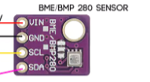

What is it? The atmospheric pressure sensor is a plate that is made up of elements such as smd resistors, smd capacitors and a “BME280” chip developed by the BOSCH company and has the technology to measure pressure, temperature and humidity.

In addition, everything is integrated in a single piezo-resistive chip thatis really compact and low energy consumption. They are also used in some applications such as: warning about dryness or high temperatures, measurement of volume and air flow, calculation of altitude for auto-pilot systems, adafruit IO (Internet of Things), home automation control, control of heating, ventilation, air conditioning (HVAC) and weather forecast

ARDUINO UNO R3

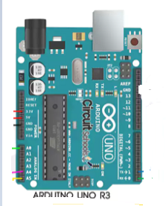

Arduino can be used to develop stand-alone interactive objects or can connected to software on your computer (e.g. Flash, Processing, MaxMSP). The open-source IDE can be downloaded for free (currently for Mac OS X, Windows, and Linux).

Arduino Uno R3 is one kind of ATmega328P based microcontroller board. It includes the whole thing required to hold up the microcontroller; just attach it to a PC with the help of a USB cable, and give the supply using AC-DC adapter or a battery to get started. The term Uno means “one” in the language of “Italian” and was selected for marking the release of Arduino’s IDE 1.0 software. The R3 Arduino Uno is the 3rd as well as most recent modification of the Arduino Uno.

Arduino board and IDE software are the reference versions of Arduino and currently progressed to new releases. The Uno-board is the primary in a sequence of USB-[Arduino boards](https://www.elprocus.com/different-types-of-arduino-boards/), & the reference model designed for the Arduino platform.The **Arduino UNO R3** is frequently used[**microcontroller board**](https://www.elprocus.com/avr-atmega8-microcontroller-architecture-applications/) in the family of an Arduino. The main advantage of this board is if we make a mistake we can change the microcontroller on the board. This board is available in DIP (dual-inline-package), detachable and ATmega328 microcontroller. The programming of this board can easily be loaded by using an Arduino computer program. The [power supply](https://www.elprocus.com/difference-between-single-phase-and-three-phase-ac-power-supply/) of the Arduino can be done with the help of an exterior power supply otherwise USB connection. The exterior power supply (6 to 20 volts) mainly includes a battery or an AC to DC adapter. The connection of an adapter can be done by plugging a center-positive plug (2.1mm) into the power jack on the board. The battery terminals can be placed in the pins of Vin as well as GND. While the Arduino UNO can be powered via the USB connection or with an external power supply, the power source is selected automatically.